**App Development with Cordova**

**Apache Cordova:**

Apache Cordova is an open-source mobile development framework. It allows you to use standard web technologies such as HTML5, CSS3, and JavaScript for cross-platform development, avoiding each mobile platforms' native development language.

Use Apache Cordova if you are:

* A mobile developer and want to extend an application across more than one platform, without having to re-implement it with each platform's language and tool set.
* A web developer and want to deploy a web app that's packaged for distribution in various app store portals.

Apache Cordova applications rely on a common config.xml file that provides information about the app and specifies parameters affecting how it works.

The application itself is implemented as a web page, by default a local file named index.html, that references whatever CSS, JavaScript, images, media files, or other resources are necessary for it to run. The app executes as a WebView within the native application wrapper. The Cordova-enabled WebView may provide the application with its entire user interface.

**Getting Started:**

**Steps:**

1. **Installing Cordova:**

* Download and Install **Node.js:**

Cordova command-line runs on Node.js**.**

Download it from <https://nodejs.org/en/download/>

* Install Cordova:

Open Node.js Command Prompt and type npm install -g cordova.

[You can find Node.js Command Prompt in Start Menu]

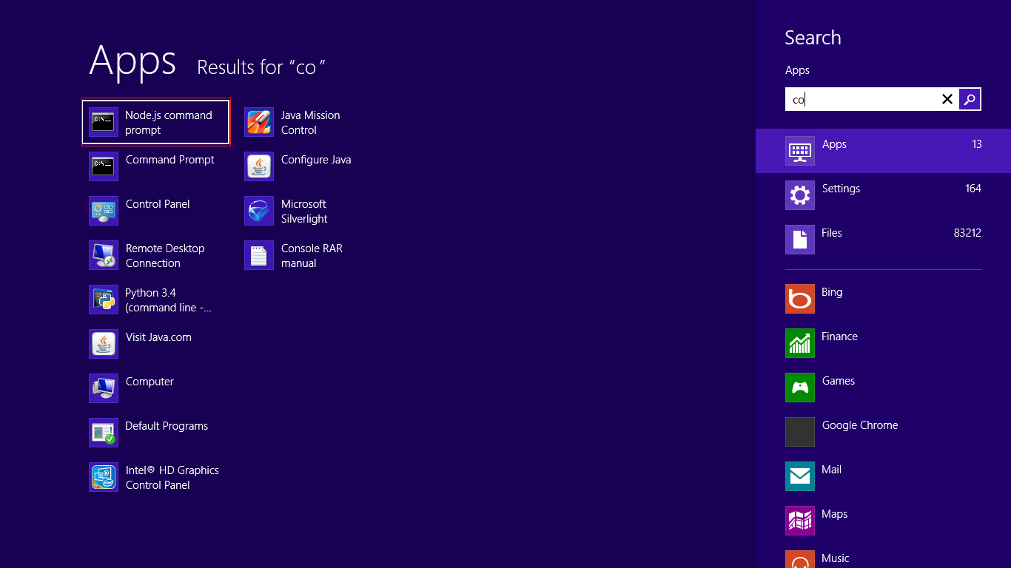

* Download **SDKs:**

You also need to download SDKs for each platform you wish to support.

<https://www.npmjs.com/package/cordova>

[For downloading android SDK: <http://developer.android.com/sdk/index.html>]

* Set **ANDROID_HOME**:

Download Android SDK and set path of ANDROID_HOME variable to the location of the Android SDK.

E.g.: D:\Shared\Android_Sdk

<http://software-testing-tutorials-automation.blogspot.in/2015/09/set-androidhome-and-path-environment.html>

* Set **JAVA_HOME**:

Set path of JAVA_HOME variable to the location of Java folder.

Eg: **C:\Program Files\Java\jdk1.8.0_65**

<https://confluence.atlassian.com/doc/setting-the-java_home-variable-in-windows-8895.html>

1. **Create a Project:**

Create a blank Cordova project using the command-line tool. Navigate to the directory where you wish to create your project and type cordova create <path>.

E.g.:

D: //for changing path to D drive

cd Projects //for entering folder (here, Projects)

Cordova create MyApp //Creating a directory for Cordova project (here, MyApp)

1. **Add a Platform:**

After creating a Cordova project, navigate to the project directory. From the project directory, you need to add a platform for which you want to build your app.

To add a platform, type cordova platform add <platform name>.

E.g.:

cd MyApp //Navigating to the project directory

cordova platform add android //Adding platform Android to the project

1. **Run your App:**

Connect your android device to your computer.

From the command line and type cordova run <platform name>.

E.g.:

Cordova run android //Running the app on Android device

**Reference:** <https://cordova.apache.org/#getstarted>

**Plugins:**

When you build and view a new project, the default application that appears doesn't do very much. You can modify the app in many ways to take advantage of standard web technologies, but for the app to communicate closely with various device-level features, you need to add plugins that provide access to core Cordova APIs.

A plugin is a bit of add-on code that provides an interface to native components.

**Reference:** <https://cordova.apache.org/docs/en/latest/guide/cli/#link-add-plugin-features>

**Icons:**

You can define app icon(s) via <icon> element (**config.xml**). If you do not specify an icon then the Apache Cordova logo is used.

For each platform you can also define a pixel-perfect icons set to fit different screen resolutions.

**Android:**

<platform name="android">

<icon src="res/android/ldpi.png" density="ldpi" />

<icon src="res/android/mdpi.png" density="mdpi" />

<icon src="res/android/hdpi.png" density="hdpi" />

<icon src="res/android/xhdpi.png" density="xhdpi" />

</platform>

The following configuration can be used to define single default icon which will be used for all platforms.

<icon src="res/icon.png" />

**Reference:** <https://cordova.apache.org/docs/en/latest/config_ref/images.html>

**Note:** For making icons of different sizes for Android and ios devices, use

<http://makeappicon.com/>